RETAIL CUSTOMER RETENTION ANALYTICS – TESCO

PREPARED BY- AKRITI TRIPATHI
COURSE- DATA SCIENCE PROJECT
TOOL USED – MICROSOFT POWER BI
DATE- 04/02/2026
OBJECTIVE
The primary objective of this project is to Analyze customer purchasing behavior and retention patterns using Power BI in order to help TESCO improve customer loyalty, reduce churn, and maximize long-term revenue.
The project aims to:
- Identify churned, repeat, and high-value customers through data-driven segmentation.
- Measure customer retention, purchase frequency, and loyalty program effectiveness.
- Evaluate the impact of promotions and discounts on customer spending behavior.
- Analyze store and regional performance to identify high-risk and high-performing locations
- Calculate Customer Lifetime Value (CLV) to understand long-term customer profitability
- Provide actionable insights and strategic recommendations for improving customer retention and business growth
Overall, the objective is to demonstrate how business intelligence and data visualization techniques can support better decision-making and help TESCO design targeted, value-based customer retention strategies.

TASK 1 DATA MODELING AND CLEANING
To understand and clean the datasets before analysis.
Steps Performed:
“In Task 1, data cleaning ensured accuracy and consistency, while data modeling established correct relationships between fact and dimension tables to support reliable analysis.”
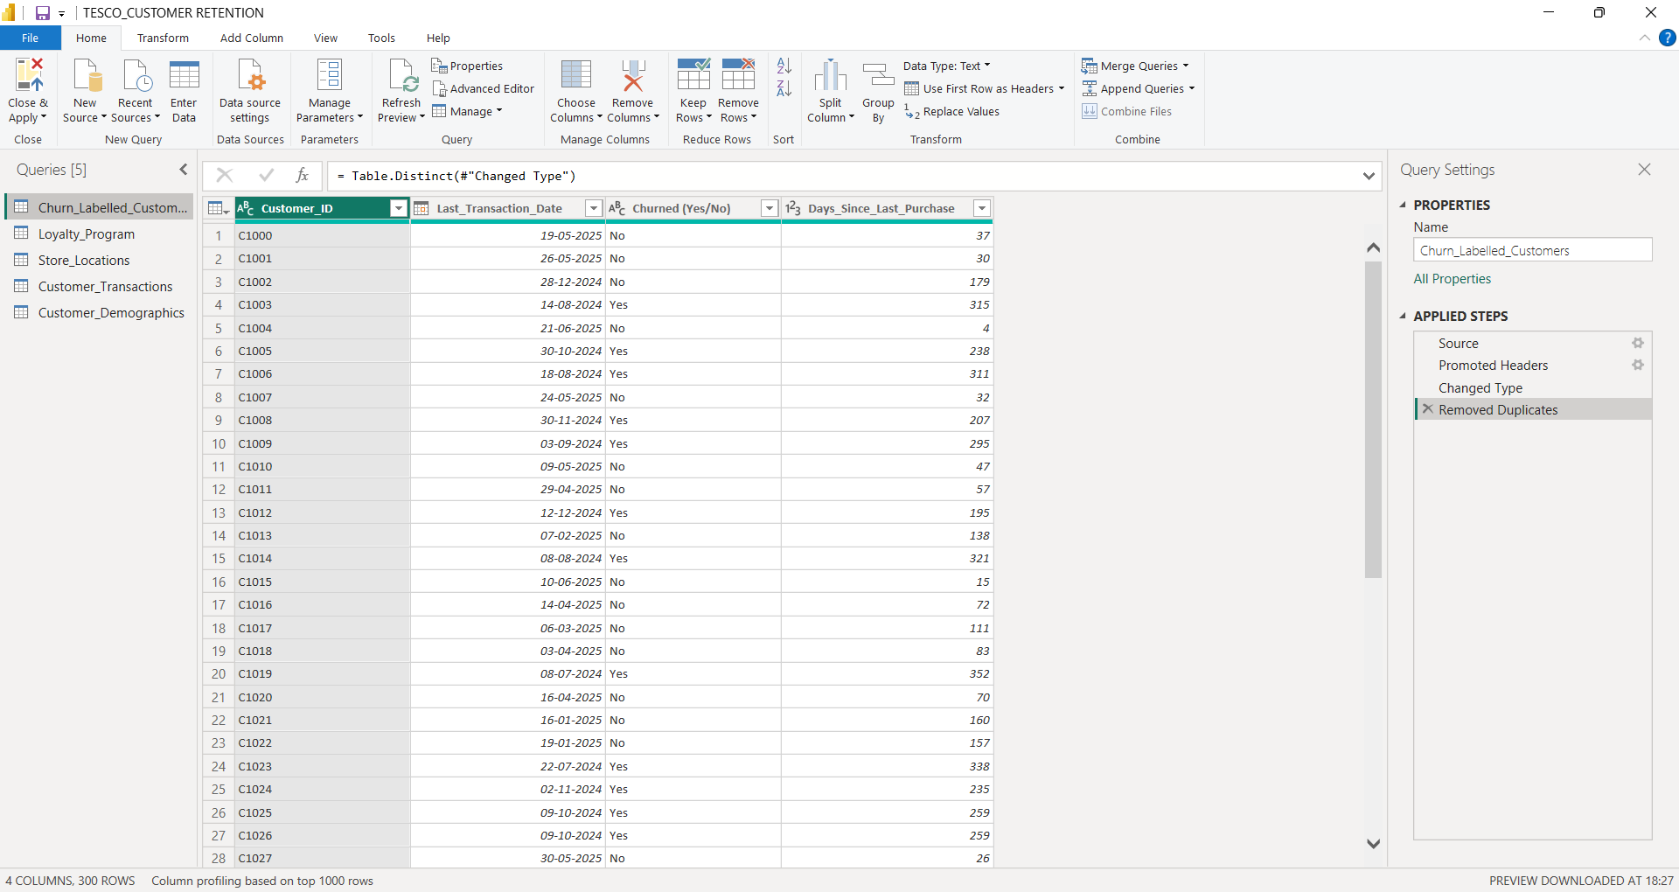
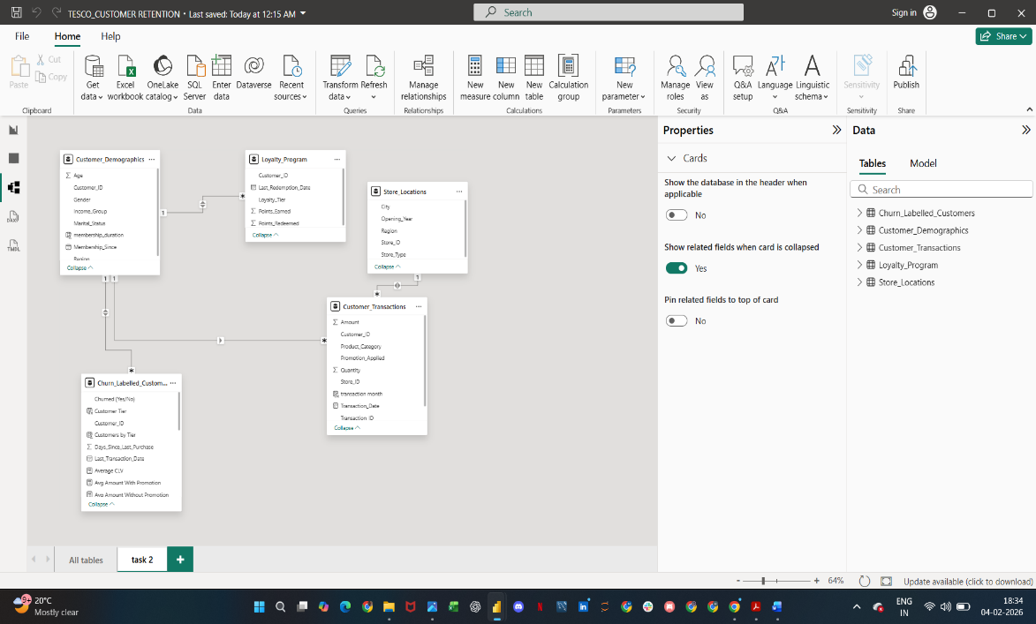

TASK 2 CHURN AND RETENTION METRICS
Task 2 focuses on defining and calculating churn and retention metrics to understand customer loss, loyalty behavior, and repeat purchasing patterns.”
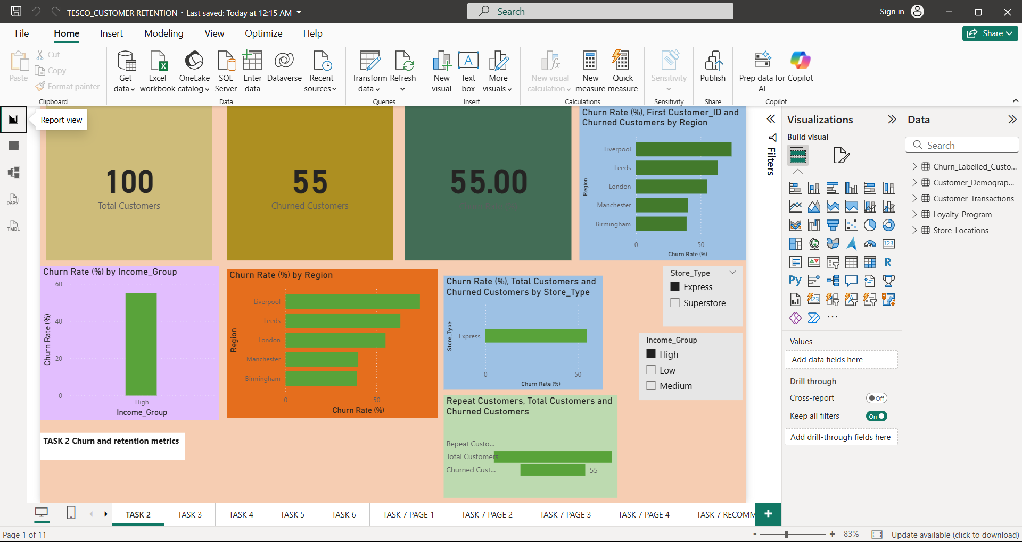

TASK 3 REPEAT PURCHASE ANALYSIS
Task 3 focuses on analyzing repeat purchase behavior to identify loyal customers and evaluate engagement patterns across segments.”
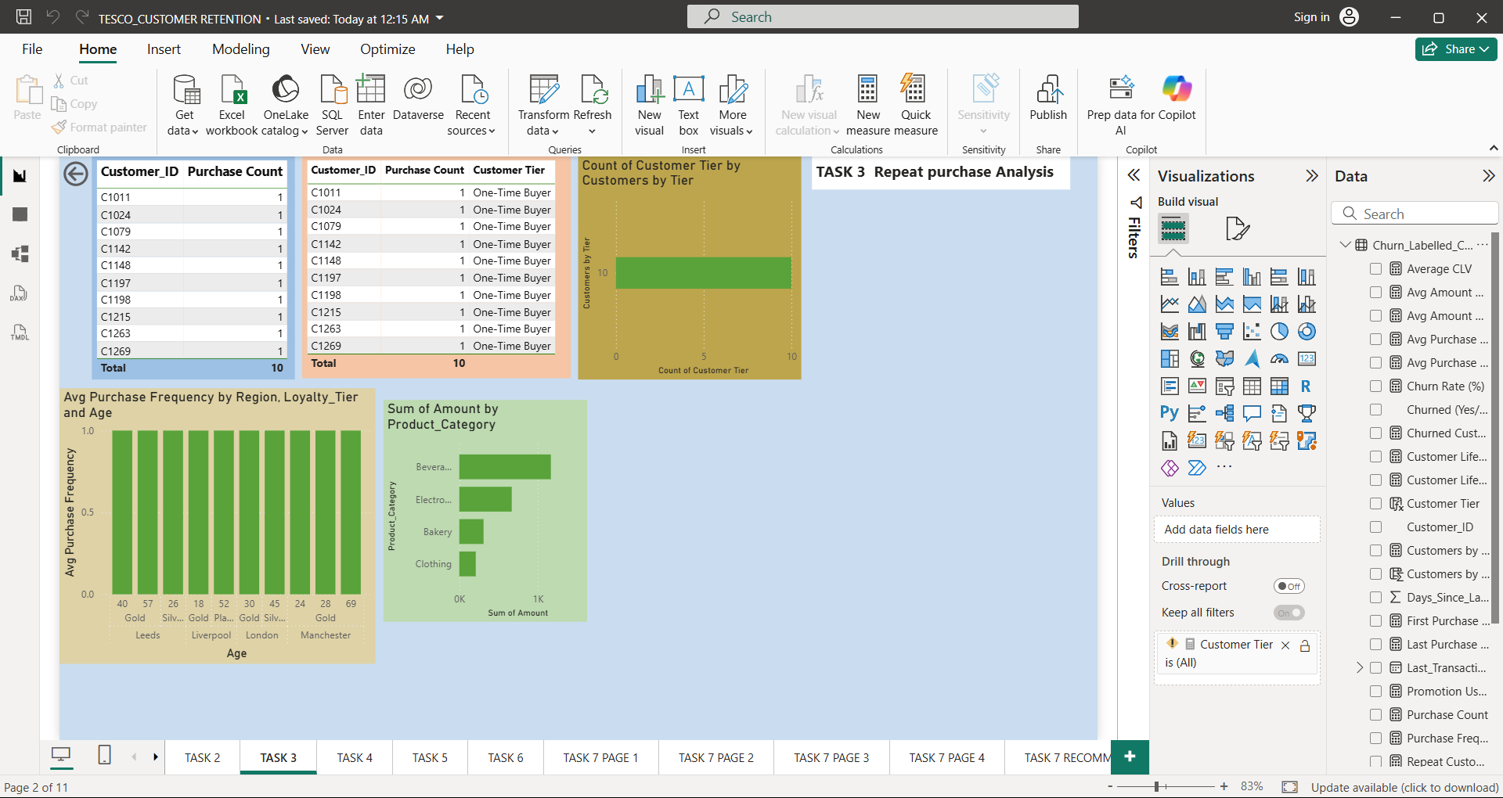

TASK 4 PROMOTION & LOYALTY IMPACT
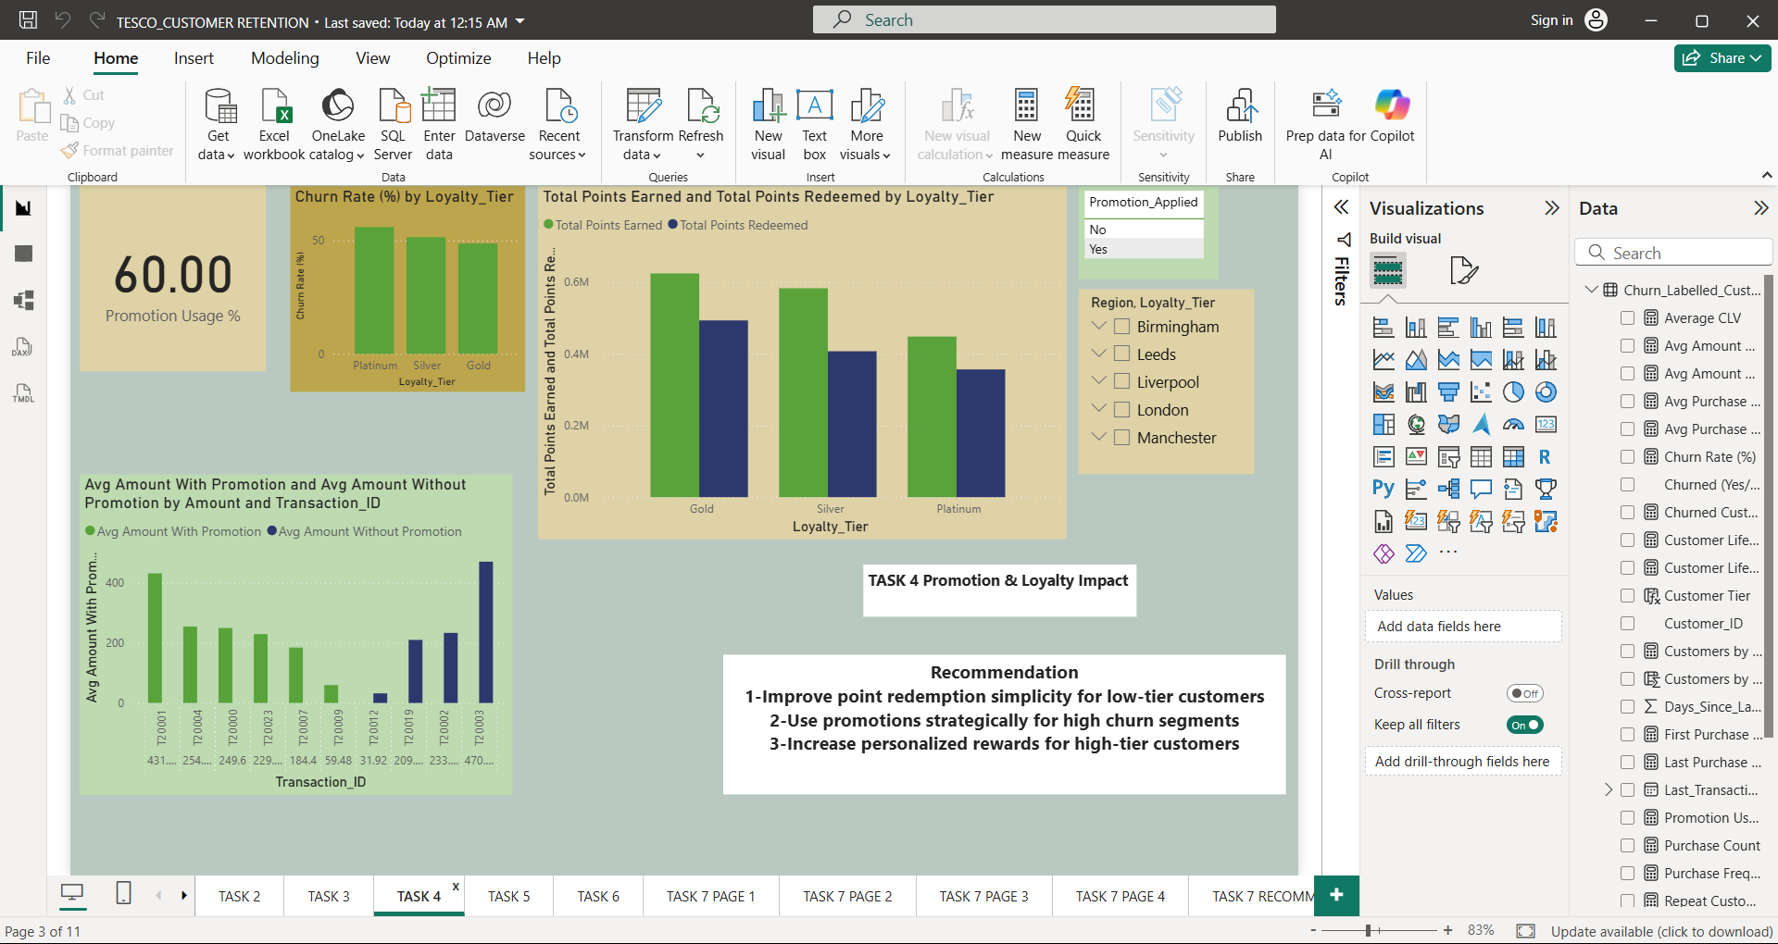
Task 4 evaluates how promotions and loyalty programs affect customer spending, engagement, and retention.”

TASK 5 STORE PERFOMANCE VS RETENTION
“Task 5 Analyze how store performance impacts customer retention, identifying high-performing and high-risk stores for targeted action.

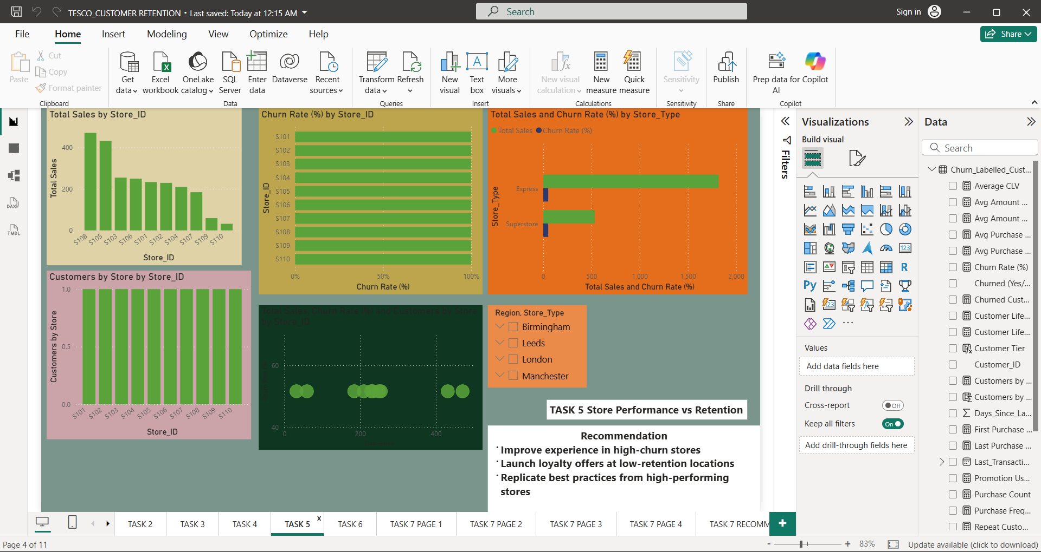

TASK 6 CUSTOMER VALUE (CLV) ANALYSIS
“Task 6 focuses on calculating and analyzing Customer Lifetime Value to identify high-value customers and quantify the revenue impact of churn.”

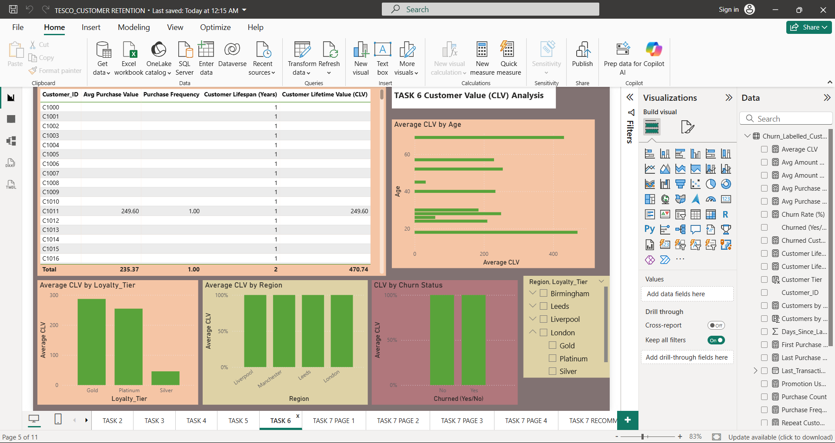

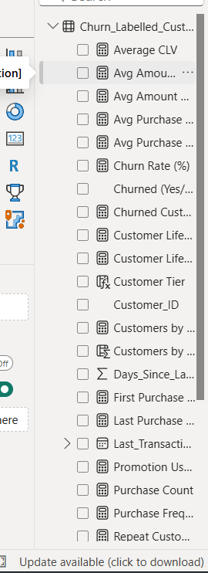

TASK 7 FINAL DASHBOARD AND EXECUTIVE SUMMARY
“Task 7 presents a final executive dashboard that consolidates all insights and provides strategic recommendations to improve customer retention and long-term value.”
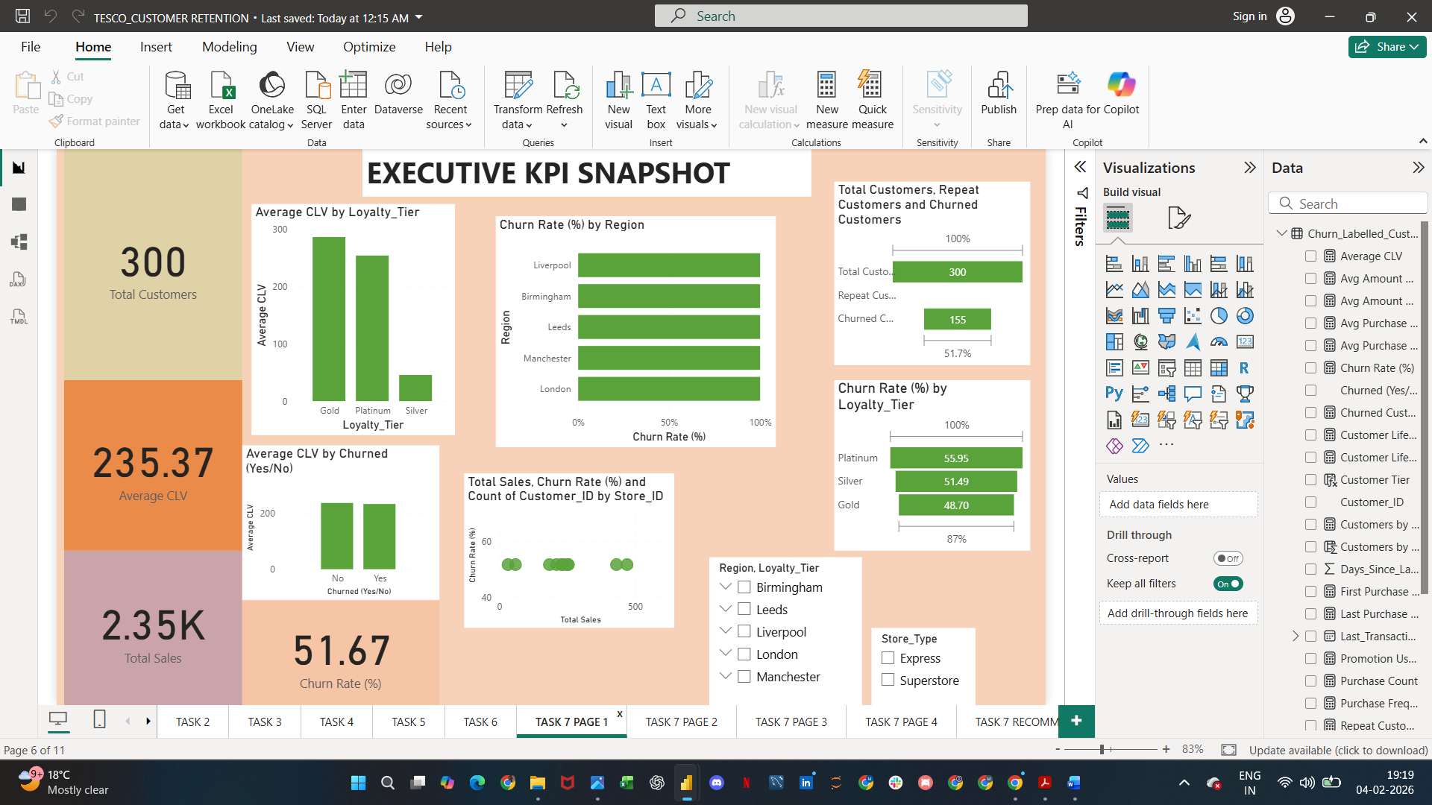

Loyalty & promotion impact
“The loyalty and promotion analysis highlights that targeted rewards and tier-based loyalty benefits are more effective for retention than mass discounting.”
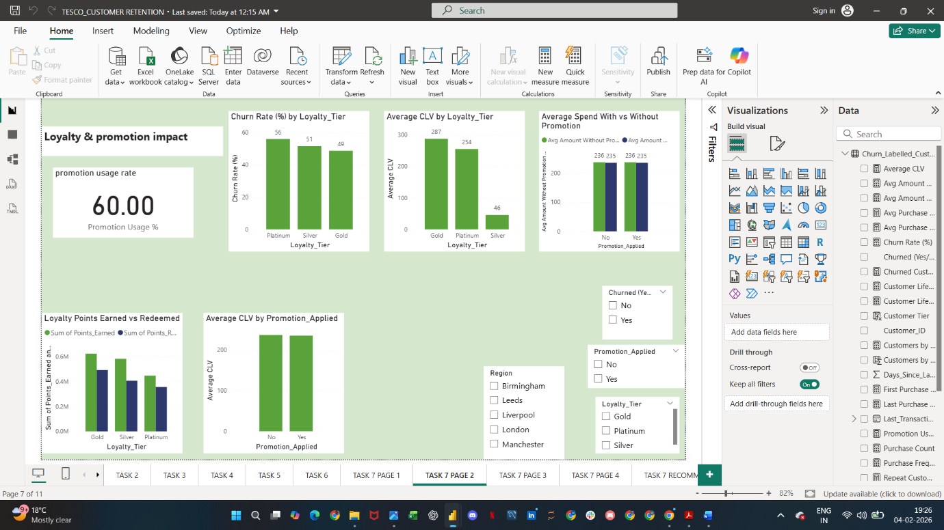

Store And Region Insights
“Store and region insights highlight performance differences across locations, helping identify high-performing areas and stores at risk of customer churn.”
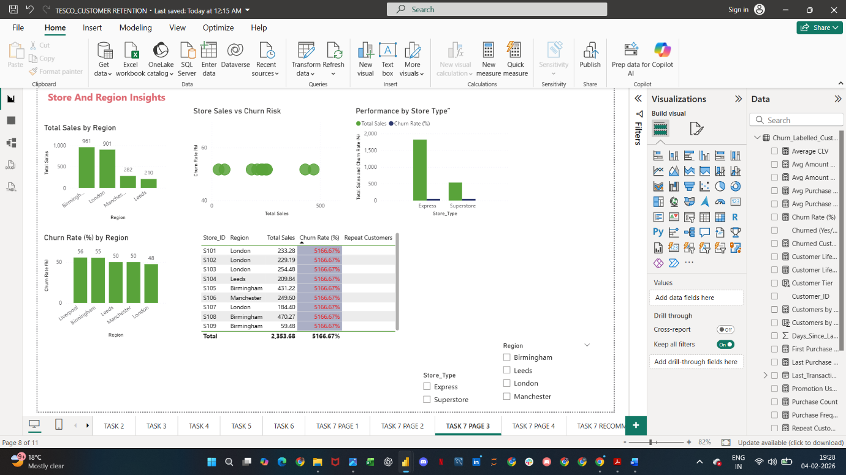

Customer Segmentation ( Churned, Repeat, High Value)

“Customer segmentation divides customers into churned, repeat, and high-value groups, enabling targeted retention and value-driven strategies
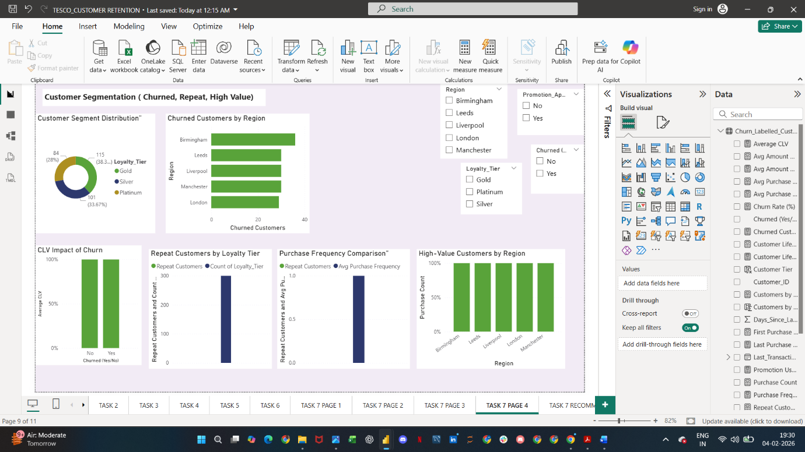

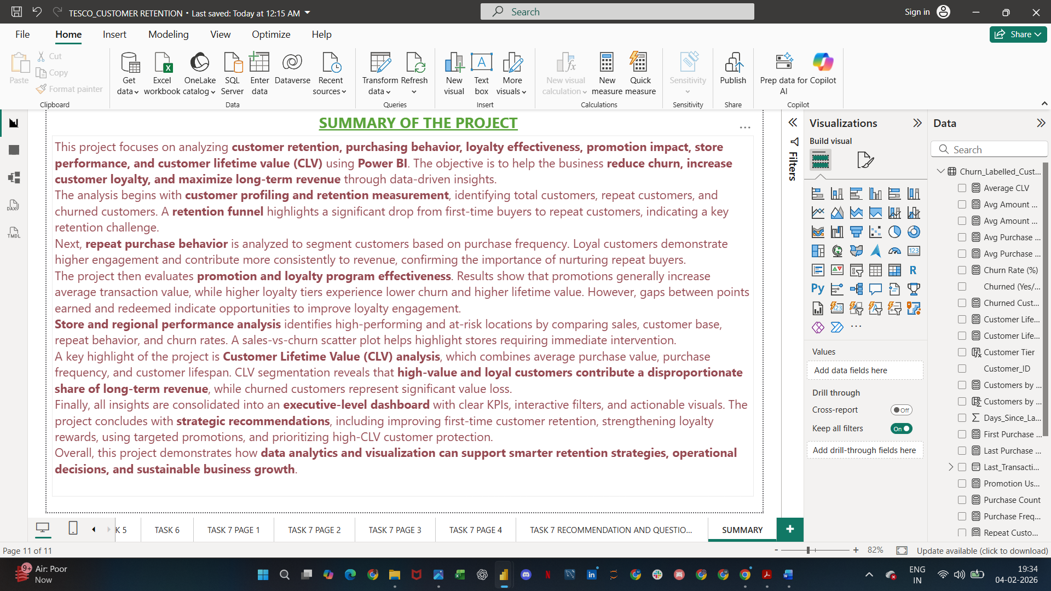

CONCLUSION
This project successfully demonstrates how data analytics and visualization using Power BI can be applied to understand customer behavior, retention, and long-term value in a retail environment. By analyzing customer purchases, loyalty engagement, promotions, store performance, and churn patterns, the project provides a comprehensive view of factors influencing customer retention.
The analysis revealed that repeat and high-value customers contribute significantly to long-term revenue, while churned customers represent a major revenue loss. Loyalty tiers with higher engagement showed lower churn and higher Customer Lifetime Value (CLV), highlighting the importance of effective loyalty programs. Promotions were found to increase transaction value, but their impact varied across customer segments, emphasizing the need for targeted and value-based promotional strategies.
Store and regional analysis identified high-performing locations as well as stores with elevated churn, enabling location-specific operational improvements. CLV analysis further strengthened the findings by quantifying customer value and helping prioritize retention efforts.
Overall, the project concludes that customer retention is more cost-effective and valuable than acquiring new customers, and that businesses like TESCO can significantly improve performance by focusing on first-time customer engagement, loyalty program optimization, targeted promotions, and protection of high-value customers. The final executive dashboard consolidates all insights into a clear, actionable format to support data-driven decision-making and sustainable business growth.
THIS IS MY VIDEO LINK
https://www.loom.com/share/fce61ea029cf44db8cb9aed86fcb6dd5

